WRAP Regional Haze Planning Workgroup

Emissions Inventory & Modeling Protocol Subcommittee

Recommendations for Base Year Modeling
DRAFT – 2/1/2019

Introduction
The Regional Haze Planning Work Group for Emission Inventories and Modeling Protocol (RHPWG EI & MP) Subcommittee solicited comments from state and local air agencies in the WRAP region on EPA's 2014 NEIv2. This work focused on pollutants and emissions sectors that had the potential to influence photochemical modeling for Regional Haze Planning, such as large PM sources and major point sources. The main criteria pollutants of concern that were reviewed for Regional Haze modeling include PM10, PM2.5, NOx, SO2, and NH3. This document briefly summarizes the 2014 NEI v2 and then lists feedback and suggested revisions received from WRAP members. The modeling contractor will use these suggestions when setting up the regional photochemical modeling system.

2014 NEI v2 State Summary
WRAP state anthropogenic emission summaries for criteria pollutants of concern are shown in the table and chart below (wildfire and biogenic emissions not included; tribal data not included).
Table 1: Anthropogenic Emissions Summary from 2014 NEI v2
State | PM10 (tons) | PM2.5 (tons) | NOx (tons) | SO2 (tons) | NH3 (tons)
Alaska | 70,736 | 14,839 | 128,307 | 9,480 | 1,097
Arizona | 285,924 | 58,413 | 216,575 | 43,634 | 33,605
California | 450,273 | 148,408 | 549,966 | 25,930 | 438,605
Colorado | 245,533 | 58,295 | 251,396 | 33,314 | 54,032
Hawaii | 73,042 | 22,144 | 49,574 | 20,714 | 7,977
Idaho | 369,524 | 74,538 | 84,236 | 7,088 | 76,487
Montana | 369,253 | 84,180 | 112,522 | 24,612 | 27,817
Nevada | 168,385 | 30,956 | 84,854 | 15,403 | 18,975
New Mexico | 437,159 | 60,108 | 185,963 | 15,049 | 20,224
North Dakota | 449,301 | 101,167 | 173,657 | 62,198 | 43,696
Oregon | 457,083 | 107,155 | 130,828 | 15,635 | 28,417
South Dakota | 347,478 | 81,526 | 68,209 | 15,948 | 62,859
Utah | 183,018 | 37,053 | 173,121 | 26,713 | 21,669
Washington | 263,775 | 90,915 | 237,184 | 30,410 | 42,435
Wyoming | 193,832 | 36,993 | 160,199 | 56,651 | 10,980

Figure 1: Anthropogenic Emissions Summary from 2014 NEI v2

2014 NEI v2 Sector Summary
WRAP state and tribal anthropogenic emission sector summaries for criteria pollutants of concern are shown in the pie charts below (wildfire and biogenic emissions not included). The top sectors are charted individually while all other sectors are lumped together. It is important to note that NEI Sector Summary data from EPA separates is aggregated by SCC, not the NAICS category. Thus, the sector summaries will split facility emissions across multiple sectors. For example, the emissions totals for “Industrial Processes – Petroleum Refineries” will be less than the total facility emissions for all petroleum refineries. This is because all boiler emissions are added into the “Fuel Combustion – Industrial Boilers, xxxxx” category, even if they are at a refinery facility.
Figure 2 shows that Unpaved Road Dust and Agricultural Dust make up more than half the PM10 emissions in the WRAP region. Figure 3 shows that Prescribed Fire, Unpaved Road Dust, and Agricultural Dust make up more than half the PM2.5 emissions in the WRAP region. Figure 4 shows that On-Road Vehicles and Coal Power Plants make up half of the NOx emissions in the WRAP region. Figure 5 shows that Coal Power Plants make up more than half of the SO2 emissions in the WRAP region. Figure 6 shows that Agricultural Activities make up 85% of the NH3 emissions in the WRAP region. More detailed sector summaries (e.g. by county) can be seen here.

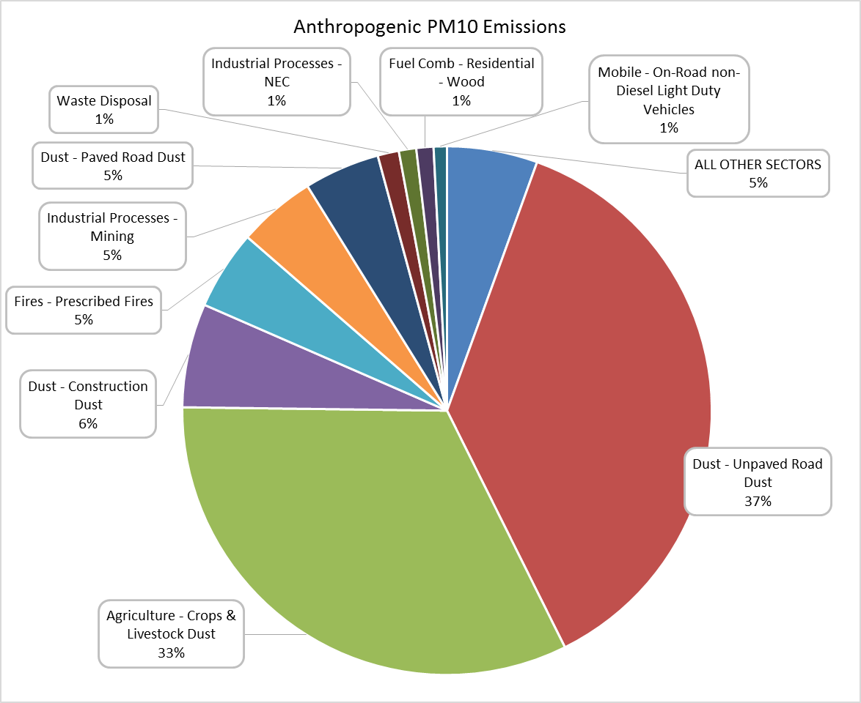
Figure 2: Anthropogenic PM10 Emissions Sector Summary 2014 NEI v2

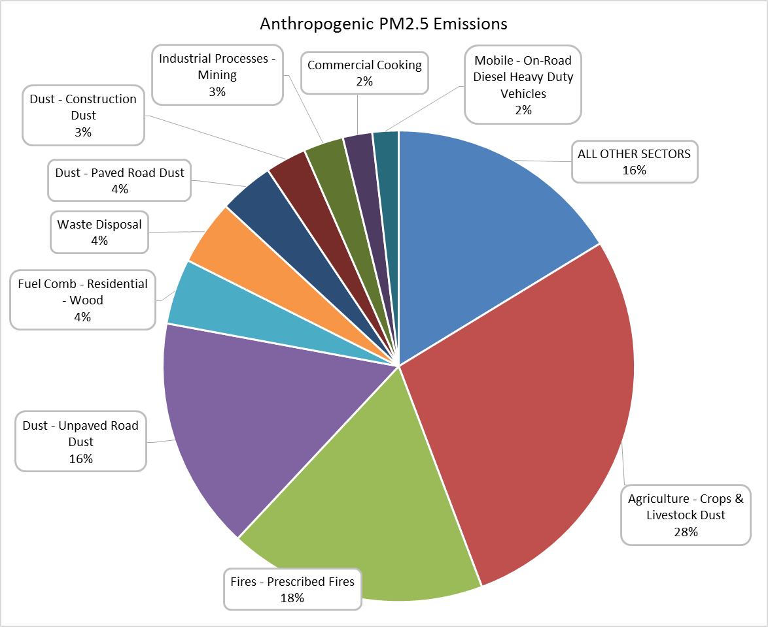
Figure 3: Anthropogenic PM2.5 Emissions Sector Summary 2014 NEI v2
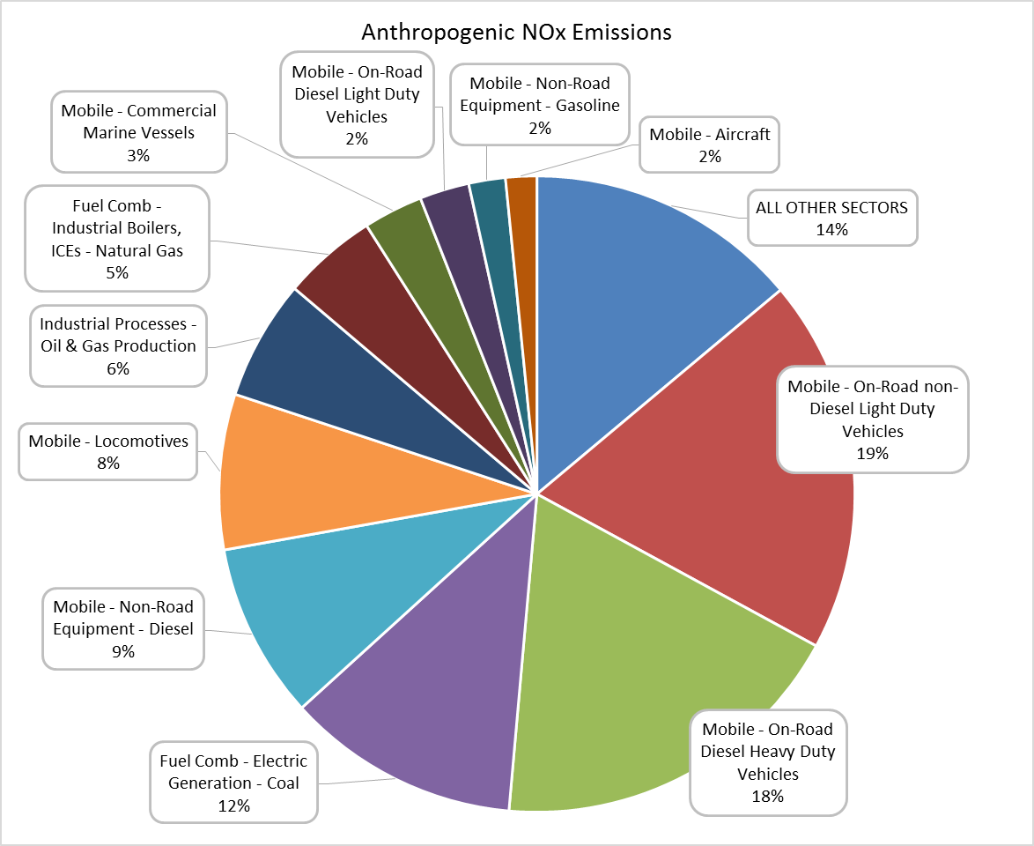
Figure 4: Anthropogenic NOx Emissions Sector Summary 2014 NEI v2

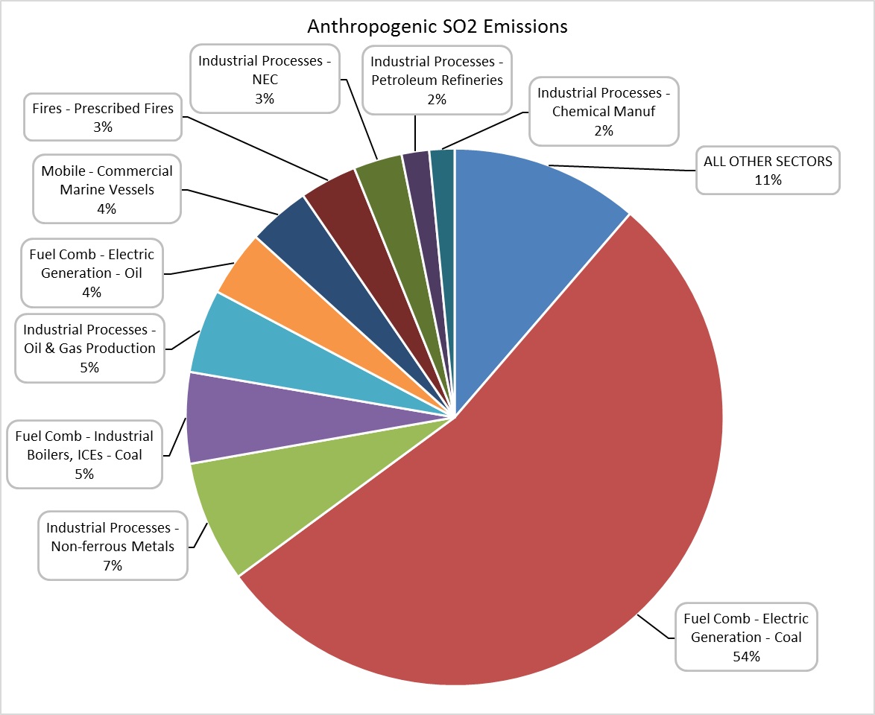
Figure 5: Anthropogenic SO2 Emissions Sector Summary 2014 NEI v2

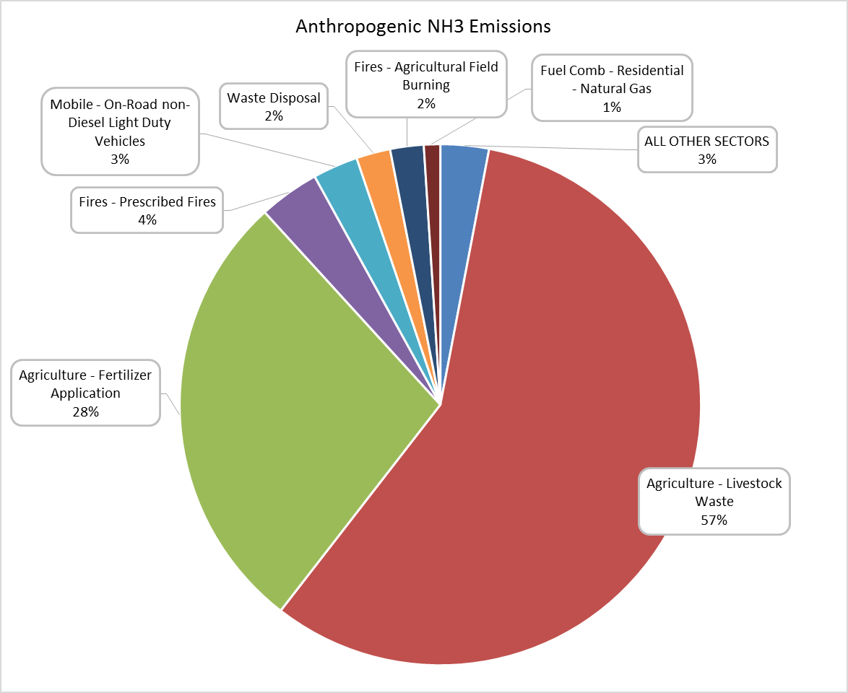
Figure 6: Anthropogenic NH3 Emissions Sector Summary 2014 NEI v2

Feedback and Revisions of the 2014 NEI v2
States and Local Agencies that are part of the WRAP spent several months reviewing the 2014 NEI v2 summary data and model-ready data. Most updates and comments came from members of the RH EI & MP Subcommittee, but many other updates were provided by WRAP members not officially on the subcommittee. The EI & MP Subcommittee started monthly meetings on June 28, 2018 and spent time reviewing all emissions sectors except for Oil & Gas and Fire, which were assigned to their respective subcommittees. This wiki page was used as the primary site for posting original NEI v2 data and the revisions/comments submitted to the subcommittee. The review process focused on sector summaries, point source facility emissions, point source stack parameters, and MOVES on-road input data. A summary of the emissions updates requested is shown in Table 2. A more detailed list of emissions updates requested and comments is shown in Table 3.
Unfortunately, not all data submitted by states was ready for model inclusion. Where possible, data was compared to the NEI v2 and reformatted as “model ready” data. The following data was not used by the contractor for the “shakeout” round: Wyoming point source data (missing information), most Pima County data (missing information), and California point-source data (incorrect format). All data that was submitted to the contractor for the “shakeout” round is listed in Table 4. Data that is scheduled to be included in the 2nd version of base year modeling include: Pima county point sources, complete state inventory for California, and Wyoming point sources. Alaska also intends to submit several emissions changes for v2 of the base year modeling.
The subcommittee also tabulated a list of the states/agencies that submit minor source emissions to EPA (see Table 5). It is important to note that when stack parameters are not included in the model-ready files for point sources, a lookup table with default stack parameters by SCC code is used. However, if a record in the model-ready file has an “erptype” = 1, the emissions process should be modeled as a fugitive source and the stack parameter lookup values will not be used.
Table 2: Summary of Emissions Updates to 2014 NEIv2 submitted to RHPWG EI & MP Subcommittee from state and local air agencies.
State/Agency | Sector | Comments | Files provided | Emissions totals in update (TpY) | Emissions totals in 2014v2 NEI (TpY) | Status/notes
California ARB | Facility point sources | Four EGU and nine nonEGU facilities missing from NEI | Facilities correction data file; stack parameters; stack reference to facility- unit- emissionsprocess | CO 11224  NH3 6.1  NOx 11830  PM10-PRI 3177  PM25-PRI 1716  SO2 3657  VOC 4257 | CO 10378  NH3 315  NOx 10724  PM10-PRI 2870  PM25-PRI 1706  SO2 2767  VOC 5461 | Data received. Update includes speciated VOCs. Stack parameters provided in supplemental spreadsheets.
Arizona, Maricopa County AQS | Facility Point Sources | Accurate point source data did not make it into the NEI for 21 sources due to a formatting error | Maricopa County point source updates | CO 1401.7  NH3 199.5  NOx 1627.1  PM10-PRI 475  PM25-PRI 470.3  SO2 78.5  VOC 755.6 | CO 1431.3  NH3 198.2  NOx 1693.7  PM10-PRI 560.8  PM25-PRI 190.9  SO2 79.9  VOC 1671.3 | Data Received
Arizona, Pima County DEQ | All for NOx, VOC | Pima EI applies to eastern half of county | Sector FF10 files, ERG report, spatial allocation files | NOx 19621  VOC 104824 | NOx 26021  VOC 219554 | Data received.
Idaho | RWC, Residential outdoor recreation | NEI lists only PM-FIL, PM-CON. Other pollutants not included in NEI; Could affect more states than ID | ID RWC correction file, includes PM-PRI (Filt + Cond) | PM10-PRI 1781  PM25-PRI 1781  NOx 198  SO2 36  VOC 1941  CO 12594  NH3 99 | PM10-PRI 926  PM25-PRI 926  NOx 118  SO2 23  VOC 691  CO 6483  NH3 54 | Data received. Update includes speciated VOCs, HAPS for selected SCCs that were not included in NEI
Washington ECY | Construction dust | EPA method underestimates values for eastern part of state | WA construction dust revisions | PM10-PRI 40627  PM25-PRI 4062.7 | PM10-PRI 20436  PM25-PRI 2043.6 | Data received
Washington ECY | RWC fireplace emissions | ECY believes estimates for four counties are grossly overestimated and wants to replace with values from EPA RWC tool v3.2 | WA fireplace emissions revisions for King, Pierce, Kitsap, Snohomish counties | CO 1356  NH3 16  NOx 24  PM10-PRI 215  PM25-PRI 215  SO2 3.6  VOC 172 | CO 17130  NH3 207  NOx 299  PM10-PRI 2713  PM25-PRI 2713  SO2 46.0  VOC 2173 | Data received. Update does not include speciated VOCs. NEI contains speciated VOCs, etc. (e.g. formaldehyde at 206 TpY).
Oregon DEQ | Unpaved Road Dust | EPA method overestimates unpaved road dust in Western Oregon | Unpaved road dust adjustments | PM10-PRI 26839  PM25-PRI 2664 | PM10-PRI 299270  PM25-PRI 29839 | Data received
Wyoming | Facility point sources | Update includes EIs for 50 Buttes and House Creek facilities | Mainline emissions file | CO 27  NOx 49  SO2 0.3  PM2.5-PRI 2.6  PM10-PRI 2.6  VOC 54 | Data for these facilities were not submitted to EPA and are not in the NEI | Data received.  Data provided include some speciated VOCs
Montana | Facility Point Sources | Many missing segments and facilities | All Point Sources | CO 2479  NOx 2633  SO2 46.9  PM2.5-PRI 437.7  PM10-PRI 2355.2  VOC 1300 | Data for these facilities or segments were not submitted to EPA and are not in the NEI | Data received. Data missing from the NEI was separated out.

Table 3: Comments and Revisions Submitted to RHPWG EI & MP Subcommittee from state and local air agencies.
State | Reviewing Agency | 2014NEIv2 Inventory | Comments | Attachments
Alaska | DAQ | Airport, marine, dust, wildfires, O&G | See attachment | Alaska comments
 | DAQ | Minor sources | List of minor sources reported for 2014 NEI | Alaska memo
Arizona | AZDEQ | All sectors | No substitutions needed | Arizona comments
 | AZDEQ | Point source stack parameters | List of descriptors for non-airport SCCs with missing stack parameters | Comments on point source SCCs, AZSCCDescriptors
 | AZDEQ | Point source stack parameters missing values | No updates | Review of missing stack parameters
 | Maricopa County AQD | nonpoint; point source; onroad | nonpoint data are accurate; there are more accurate point source data that did not make it into the NEI due to a formmating error; onroad looks OK | Maricopa County comments, Maricopa County point source updates
 | Pima County DEQ |  | Attached data were not submitted to EPA for inclusion into the 2014 NEIv2 dataset. These are Pima DEQ’s best estimates for 2014. Inventories include annual NOx and VOCs, along with OSD, estimates. Note that inventories represent the eastern portion of Pima County. | Pima County comments, Pima_County.zip
 | Pinal County | All sectors, including unpaved road dust | EI person is reviewing; will respond with comments | Pinal County comments
 | Albuquerque | All sectors | No need for any changes | Albuquerque comments
California | CARB | Mobile Sources | Email thread regarding use of CA's EMFAC vs. EPA's MOVES model for mobile source emissions | CARB Comments
 | CARB | Facility point sources | Correction data file for point source emissions from 13 facilities | Facilities correction data file, Facilities correction memo
 | CARB | Facility point sources | Stack parameter updates for point source emissions | CARB Stack Parameter Corrections, Stack Reference to Facility-Unit-Emissions, Stack parameters update memo
 | CARB | Nonpoint, Nonroad | see attachment | CARB Comments Huth
 | CARB | nonpoint updates in FF10 format | Zip file containing one file to remove cattle husbandry dust from solid waste categories; three files with "hard zeros" for various pollutants and counties in sectors relating to industrial boilers, oil and gas, and poultry husbandry. | California FF10 updates; Memo Huth
Colorado | CDPHE | All sectors | Sectors appear consistent with [Colorado] data | Colorado Comments
 | CDPHE | Onroad Mobile | Issue with how EPA treated vehicle age distributions in 2014 NEI | Colorado comments on MOVES vehicle age distribution
Hawaii | HDoH | See comments and data attachments | See attached comments | Hawaii comments; Hawaii Comparison of Phase 1 spreadsheet to HI SLEIS; HI Data Pt Src review
Idaho | IDEQ | Residential wood combustion | Updates to 2014v2 RWC inventories for Idaho | Idaho Comments; 2014 NEIv2 RWC Corrected
Montana | MTDEQ | All sectors | No changes to 2014 NEI; potential issues with O&G inventories in Big Horn Basin (review pending) | Montana Comments
 | MTDEQ | Stack parameters | Updates for Oldcastle facility | Oldcastle update file, Montana memo
 | MTDEQ | oilgas, ptegu, ptnonipm | Data missing from NEIv2 | MT updates for oilgas ptegu; MT updates for oilgas ptegu ptnonipm data
Nevada | NDEP | All sectors, emphasis on major point sources | No changes at this time; Washoe County indicated their MOVES inputs were not included | Nevada comments
 | Clark County | All sectors | Data are OK to use as is | Clark County comments
 | Washoe County | all sectors | NEI data are correct for Washoe County | Washoe County comments
 | NDEP | default stack parameters | Clarification on fields in default stack parameter file | NDEP Memo Harpring
New Mexico | NMENV | All sectors | EPA’s change in methodology from 2011 to 2014 reduced road dust emissions by 50%. In 2014, VMT was obtained from a MOVES run instead of an NMIM run, and separated into paved and unpaved values based on census-region level ratios. | New Mexico Comments 1, New Mexico Comments 2
North Dakota | DoH | Point source stack parameters | Stack parameter replacements for a couple of their coal power facilities, noted in red (columns S thru W) | 2014NEIv2_stack_revisions_ND
 | DoH | Point sources and other sectors | Inventories look reasonable | North Dakota Comments
Oregon | ODEQ | nonpoint nonroad onroad | EPA data is accurate for Oregon nonpoint, nonroad and onroad sources. See comments. | Oregon Comments
 | ODEQ | Point sources | EPA data are accurate for Oregon point sources | Oregon Comments Swab, Oregon Comments Stocum, Point source review materials
 | ODEQ | Unpaved Road Dust | Review by the RHPWG EI & MP Subcommittee indicates abnormally high values for OR | Email correspondence indicating WA may provide updates for OR unpaved road dust emissions
 | LRAPA | Major point sources | Updates provided to EPA. Pending confirmation that correct data is in NEI | Oregon LRAPA comments
 | ODEQ | Unpaved roads | Adjustments made by WA-ECY | Unpaved road adjustments, map showing revisions, Memo
South Dakota | DENR | All sectors | No changes | South Dakota Comments
Utah | UDEQ | non-point SOx, non-road mobile diesel locomotive SO2 | Updates provided, other sectors look OK for RH modeling | Utah Comments, SOx Discrepancy - OpenBurning LandClearing, Mobile Sources Comparison
Washington | ECY | Construction Dust | EPA's emissions calculation methodology for construction dust is over-generalized for Washington state | Washington Comments, WA_2014_ConstructionDust_EI_Revisions.xlsx
 | ECY | Fireplace emissions | Updated fireplace emissions for four counties in the Puget Sound area | WA_2014_Fireplace_EI_Revisions.xlsx WA_2014_Fireplace_EI_Revisions.docx
Wyoming | WDEQ | Unpaved road; point sources | Raised concerns for Unpaved Road Emission; recommendations for representativeness of point source emissions | Wyoming Comments
 | WDEQ | Facilities emissions not in NEI | See attached | 50 Buttes and House Creek Emissions

Table 4: Data Files Submitted to Contractor for 1st version (shakeout) of Regional Haze Base Year Modeling.
Data Transfer | State | filename | Action Taken | Comments
Part 1 | AZ | Maricopa_Point_updated.csv | Replaced NEI data | Included in Shakeout Round
Part 1 | MT | MT_OldCastle_ptnonipm_ADD.csv | Added to NEI data | Included in Shakeout Round
Part 1 | AZ | Pima_Aircraft_Annual_FF10.txt | Not Used | Incomplete Data Set
Part 1 | AZ | Pima_Area_Annual_FF10.txt | Added to NEI data | Included in Shakeout Round
Part 1 | AZ | Pima_Line-Locomotives_Annual_FF10.txt | Added to NEI data | Included in Shakeout Round
Part 1 | AZ | Pima_Point_Annual_FF10.txt | Not Used | Incomplete Data Set
Part 1 | AZ | Pima_Yard-Locomotives_Annual_FF10.txt | Added to NEI data | Included in Shakeout Round
Part 1 | WA | WA_RWC_nonpoint_updated.csv | Replaced NEI data | Included in Shakeout Round
Part 2 | CA | CA Hard zeros for industrial boilers.csv | Replaced NEI data | Included in Shakeout Round
Part 2 | CA | CA Hard zeros for layer and broiler wastes.csv | Replaced NEI data | Included in Shakeout Round
Part 2 | CA | CA Hard zeros for O&G production.csv | Replaced NEI data | Included in Shakeout Round
Part 2 | ID | ID_RWC_updated.csv | Replaced NEI data | Included in Shakeout Round
Part 2 | OR | OR_UnpavedRdDust_updated.csv | Replaced NEI data | Included in Shakeout Round
Part 2 | UT | UT_LandClr_SO2_updated.csv | Replaced NEI data | Included in Shakeout Round
Part 2 | WA | WA_ConstDust_updated.csv | Replaced NEI data | Included in Shakeout Round
Part 3 | ND | ND_ptegu_updated.csv (stack update) | Replaced NEI data | Included in Shakeout Round
Part 4 | MT | ptnonipm_Montana_Missing_Data.csv | Added to NEI data | Included in Shakeout Round
Part 4 | MT | oilgas_Montana_Missing_Data.csv | Added to NEI data | Included in Shakeout Round
Part 4 | MT | ptegu_Montana_Missing_Data.csv | Added to NEI data | Included in Shakeout Round

Table 5: Status of minor-sources included in the 2014 NEI v2 point-source facility dataset
State | Minors Submitted to EPA?
Alaska | Yes (see updates on wiki)
Arizona | Pima County says No – AZDEQ: No
California | Yes - All minors submitted for NEI years
Colorado | Yes - All sources down to 1 ton
Hawaii | No
Idaho | No
Montana | Yes – Sources down to 25 tons except portables
Nevada | Yes - All minors submitted for NEI years
New Mexico | No
North Dakota | No
Oregon | No
South Dakota | No
Utah
Washington | No
Wyoming | Yes - All minors submitted for NEI years

